IP01 | BREAKING LINES
NC ADVANCED SESSION PLAN | FAW-ALIGNED STRUCTURE
PREPARE | CONNECT | RECOGNISE | CREATE | EXPLOIT | TRANSFER | REFLECT
Moment | In Possession
Age Group | U16
Duration | 90 minutes
Reference Formation | 4-4-2 (reference structure; IP/OOP occupation may change)
Primary Principle | Breaking Lines
Supporting Principle | Create & Exploit Overload
Session Outcome | Recognise pressure -> select the appropriate solution -> create/access the spare player -> break a line -> exploit the resulting advantage.
FAW WELSH WAY PRINCIPLE
BREAKING LINES Understand when and how to play through, around or over the opposition based on the type of pressure applied.
Supporting principle: Create & Exploit Overload - understand when and how to exploit a numerical advantage against the opposition.
SESSION RATIONALE
The session moves from physical preparation and position-specific reference pictures into increasingly representative football problems. The practices are linked by one learning objective rather than operating as isolated drills. Constraints are introduced only when observation indicates that the desired behaviour is not emerging.
REFERENCE 4-4-2 ROLES
• 1 - Goalkeeper | 2/3 - Full backs | 4/5 - Centre backs | 6/8 - Central midfielders | 7/11 - Wide midfielders | 9/10 - Forwards.
• Out of possession: compact 4-4-2 reference. In possession: retain width, depth, balance and occupation between/beyond lines rather than forcing a rigid fixed shape.

SESSION TIMELINE
0-10 | S&C / Physical Preparation - PREPARE
10-22 | Position Specific 4-4-2 - CONNECT
22-37 | Practice A: Possession - RECOGNISE
37-52 | Practice B: Continuous Possession - CREATE
52-67 | Practice C: Directional SSG - EXPLOIT
67-87 | 4-4-2 Game - TRANSFER & CONSOLIDATE
87-90 | Player Debrief - REFLECT
COACHING METHODOLOGY
• Coach primarily one team and manage the opposition to provide realistic pressure and defensive behaviour.
• Use concurrent, individual, terminal, walk-through and coaching-process interventions according to the picture presented.
• Do not stop the practice merely to deliver planned content. Observe first; intervene when the intervention can improve understanding.
• Use questions and environmental manipulation before automatically giving the solution.
• Progressions and regressions are options, not compulsory stages.
• Primary observation lens throughout: is the player's decision based on the pressure applied?
OPPOSITION REFERENCE BEHAVIOUR
• Protect central space and remain connected.
• Prevent or discourage split passes.
• Force play outside where appropriate.
• Protect space behind the defensive line.
• On regain, transition positively to maintain realism.
SESSION SUCCESS INDICATORS
• Players recognise when the central route is available and play through with appropriate timing and quality.
• Players recognise when pressure protects the centre and can progress around it without treating circulation as the end objective.
• Players recognise when high/compact pressure creates space beyond and can play over appropriately.
• Ball carriers recognise when nobody engages and carry forward to commit an opponent.
• Players create and access spare players rather than simply passing because a numerical overload exists.
• After breaking a line, players accelerate the attack and exploit the temporary advantage before the opposition reorganises.

1 | S&C / PHYSICAL PREPARATION - PREPARE
Duration | 10 minutes
Practice Type | Physical preparation / activation
Purpose | Prepare players physically and cognitively for the movement demands of Breaking Lines.
Ownership | S&C-led; football plan defines outcomes rather than prescribing the exact physical programme.
Physical emphasis: Multidirectional movement; acceleration/deceleration; change of direction; hip mobility/opening; short explosive actions; reaction to visual information; readiness for repeated high-intensity football actions.
Football connection: Where appropriate: check away -> accelerate to receive; open body -> change direction; receive -> move again; support underneath -> accelerate beyond.
Coach observation: Players finish physically prepared to enter football work immediately. No tactical lecture is required in this phase.
TRANSITION Position-specific equipment should already be set so the session moves directly from physical preparation into football.

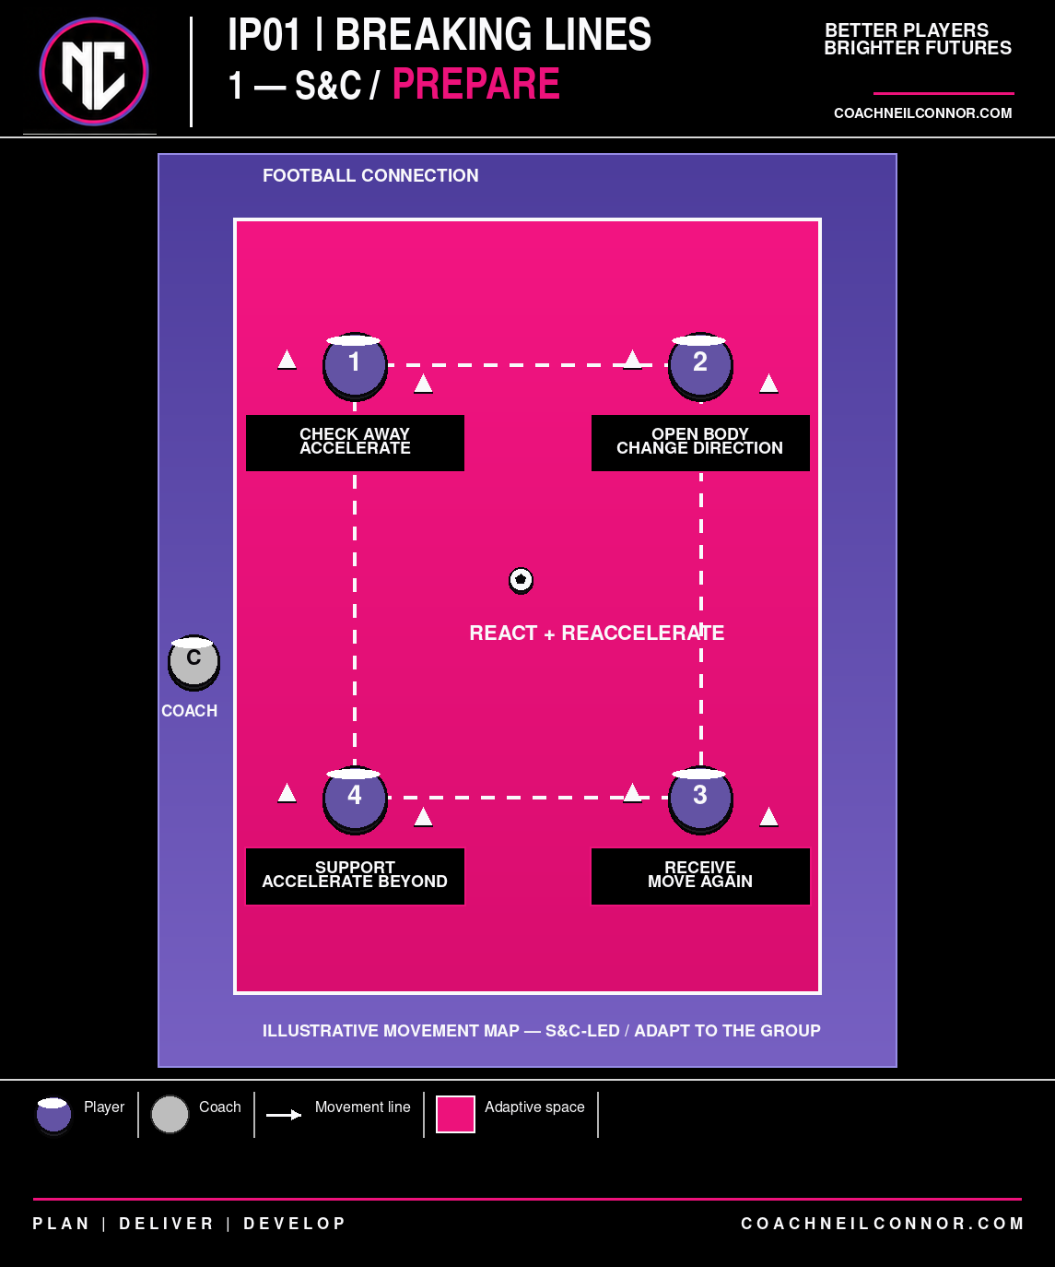

2 | POSITION SPECIFIC 4-4-2 - CONNECT
Duration | 12 minutes
Practice Type | Position Specific
Reference | 4-4-2 positional relationships
Primary Purpose | Connect the Breaking Lines principle to recognisable positional relationships.
Organisation: Use both sides where numbers permit. Start from realistic 4-4-2 reference positions. Present a small number of starting pictures, then progress to choice based on the defensive pressure.
• THROUGH - CB -> CM -> Forward. 6/8 moves beyond first pressure and receives to play forward; 9/10 provides depth/connection.
• AROUND - Central route blocked. CB -> FB -> wide midfielder/CM -> forward. Going around pressure should reopen forward access rather than become harmless circulation.
• OVER - High/compact pressure leaves space beyond. GK/CB recognises the opportunity; 7/11/9/10 provide appropriate movement.
• CARRY - Defender does not engage. CB/CM carries forward to commit pressure and create a spare player.
Positional detail: GK: scan/support/pass range. CB: body orientation, carry, disguise, forward pass. FB: width and timing. 6/8: escape cover shadow, scan, receive to play forward. 7/11: width/inside movement/beyond. 9/10: pin, connect, show or threaten behind.
Progression (Harder): Move from reference pictures into choice. Change the defensive pressure so the players must diagnose through, around, over or carry.
Regression (Easier): Reduce or temporarily remove opposition pressure to rehearse the positional relationship, then reintroduce the decision.
Coach Observation: Avoid turning the practice into choreography. The key evidence is whether players identify the correct solution when the picture changes.

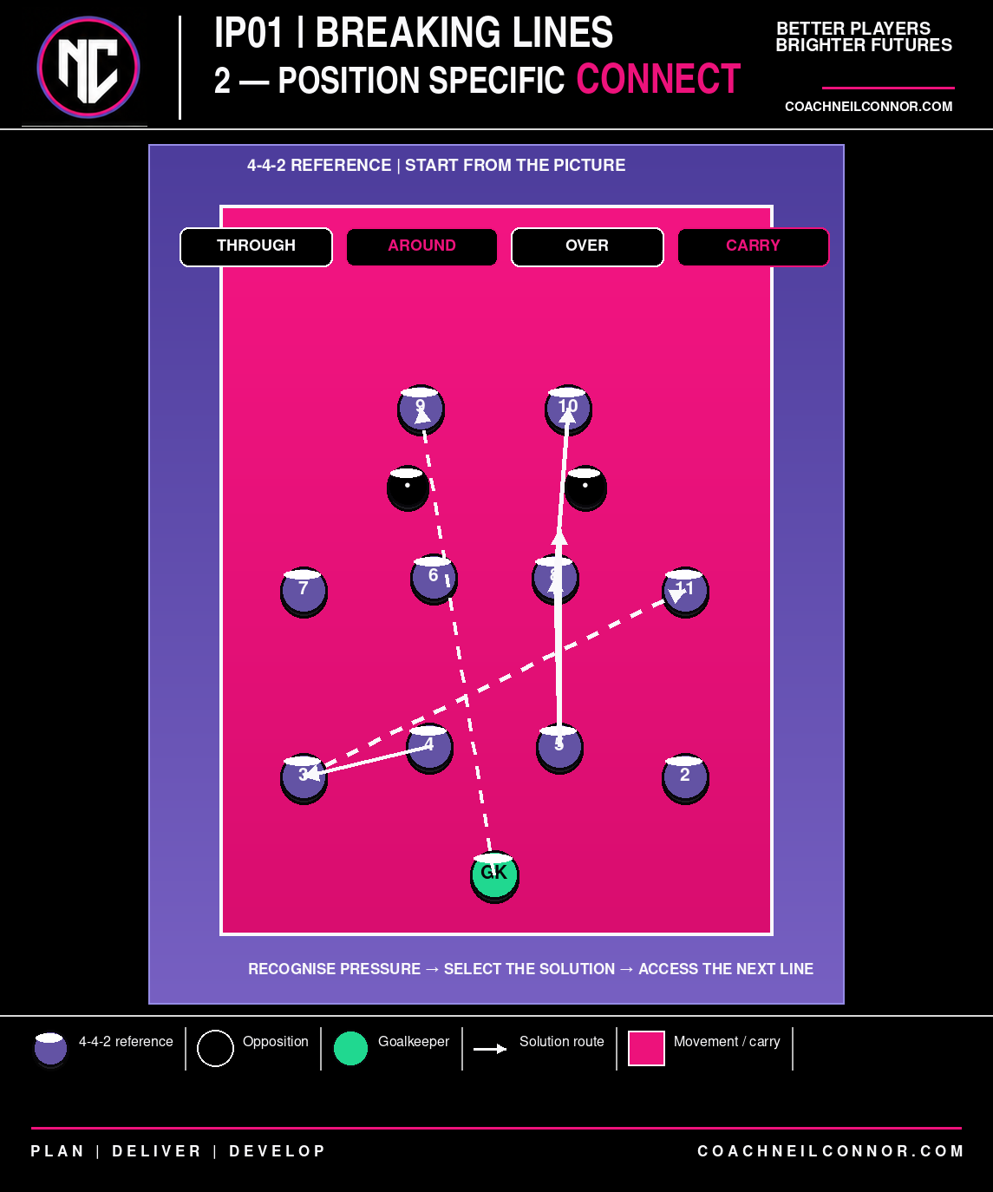

3 | PRACTICE A - RECOGNISE
Duration | 15 minutes
Practice Type | General Practice / Possession
Organisation | 6v6 + 3 common players; two end targets and one internal common player.
Area | Approx. 25m x 30m; adapt to numbers and success rate.
Focus | Recognise how to break opposition pressure.
Explanation: The possession team transfers the ball from one end common player to the other. The internal common player supports the team in possession. After a successful transfer, possession continues and direction reverses.
PLAYER PROBLEM Can we recognise how to get from one end to the other based upon the pressure?
Start condition: Free play. No touch restriction, mandatory split pass or compulsory use of the common player.
Technical detail: Scan before receiving; receive to see forward; first touch away from pressure; appropriate weight/direction; disguise; dribble/run with the ball when space is available.
Tactical detail: Through / around / over / carry; width and depth; move away from cover shadows; support underneath; movement beyond; recognise the spare player; play forward when appropriate.
Challenges / Conditions / Targets: Begin without conditions. If required: successful end-to-end transfer = 1 point; transfer involving a genuine line-breaking action = 3 points.
Progression (Harder): Reduce space; restrict common-player time; allow pressure on end common players; remove the internal common player.
Regression (Easier): Increase area; give common players greater freedom; reduce opposition numbers/pressure.
Coach Questions: What does the pressure give us? Where is the spare player? Can we play forward? If the middle is protected, what is available?
Coach Observation: Do not equate Breaking Lines only with a split pass. Judge whether the players recognise the solution offered by the pressure.

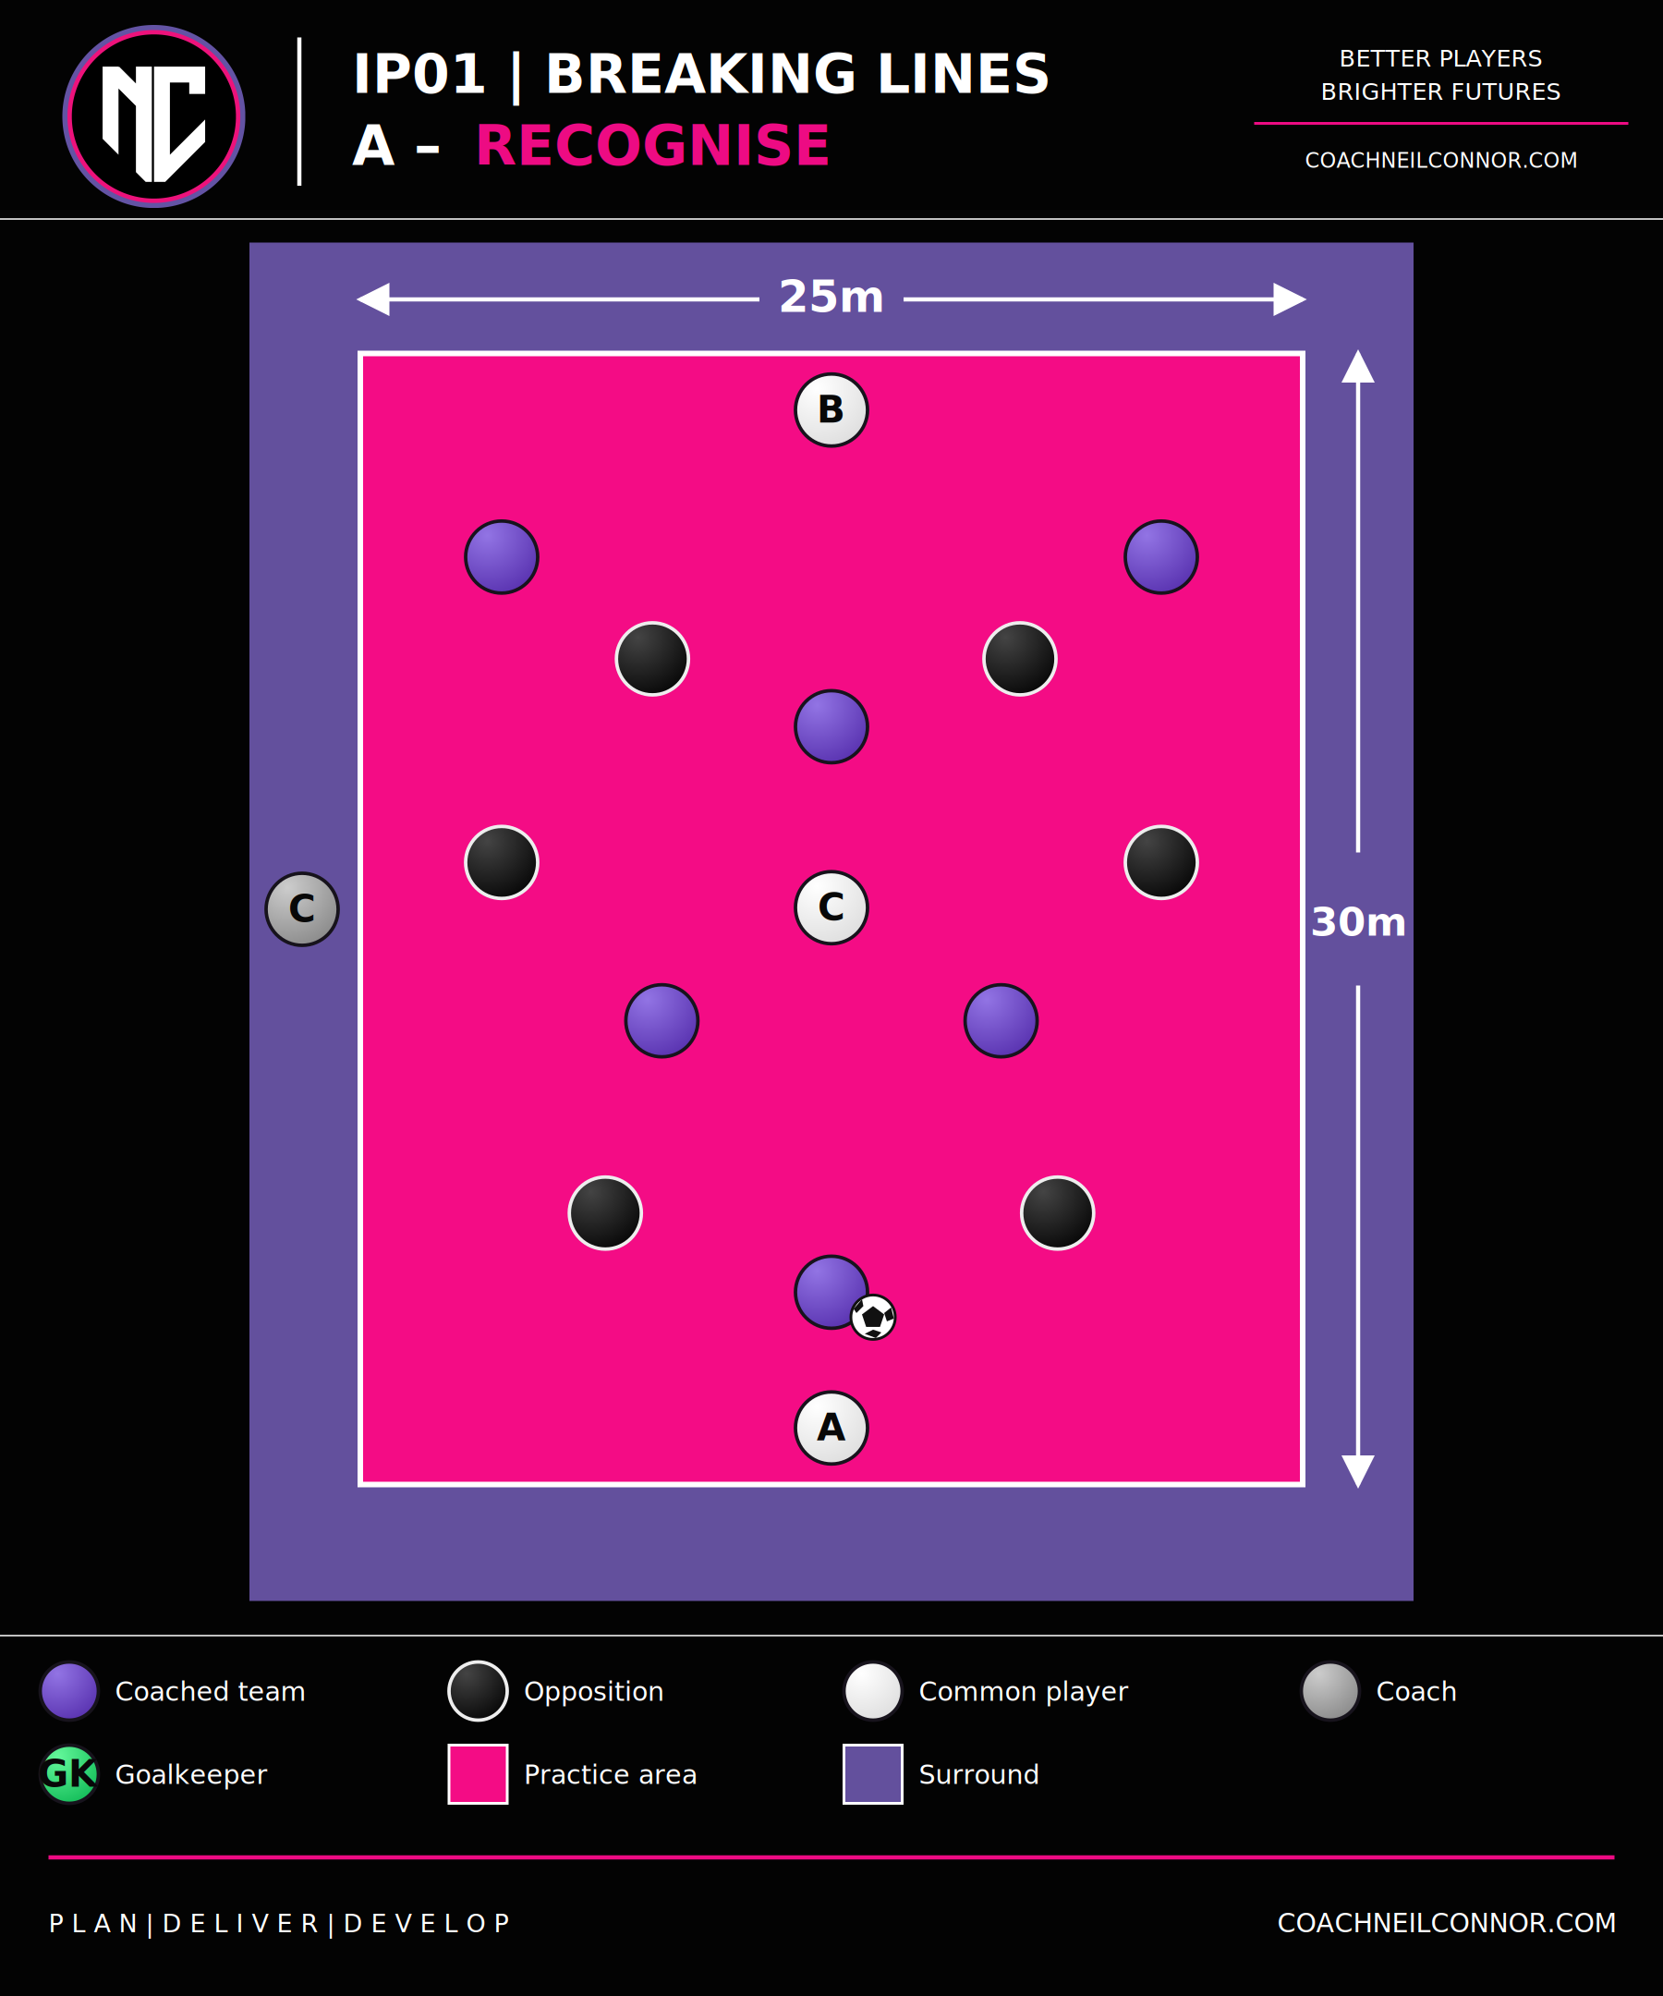

4 | PRACTICE B - CREATE
Duration | 15 minutes
Practice Type | General Practice / Continuous Possession
Organisation | 7v6 + 3 common players: two end targets and one internal common player. Approx. 25m x 30m. Reference thirds guide depth; players can move freely across them.
Focus | Create and exploit the advantage to break a defensive line.
PLAYER PROBLEM Can we manipulate the defender to create the line-breaking opportunity?
Explanation: Connect one end target to the other, then retain possession and reverse direction. Common players support either team. On regain, connect with an end target and work towards the other. Start with free touches and protected end boxes. A controlled transfer scores 1; optionally award a second point when drawing an opponent creates forward access. Rotate common and extra-player roles.
Key behaviour: Carry -> Commit -> Release -> Move, but not as a compulsory sequence. If the defender does not engage, continue carrying.
Coaching detail: Find the spare player; effective width; support angle/distance; carry at the defender; commit; timing of release; overlap/underlap; movement beyond; combination play; accelerate after elimination.
Progression (Harder): Reduce purple to six for balanced outfield numbers; remove the internal common player; narrow the area; or allow controlled pressure on an end target as the pass travels. Change one variable at a time.
Regression (Easier): Increase width; temporarily protect the internal common player; or allow an uncontested first reception on restarts. Retain free touches while players learn to recognise the available options.
Coach Questions: Who is spare? What happens if the defender does not come? Can you make them commit? When should you release it?
Coach Observation: Do not reward passing merely because an overload exists. The correct decision may be to retain and carry the ball until pressure commits.

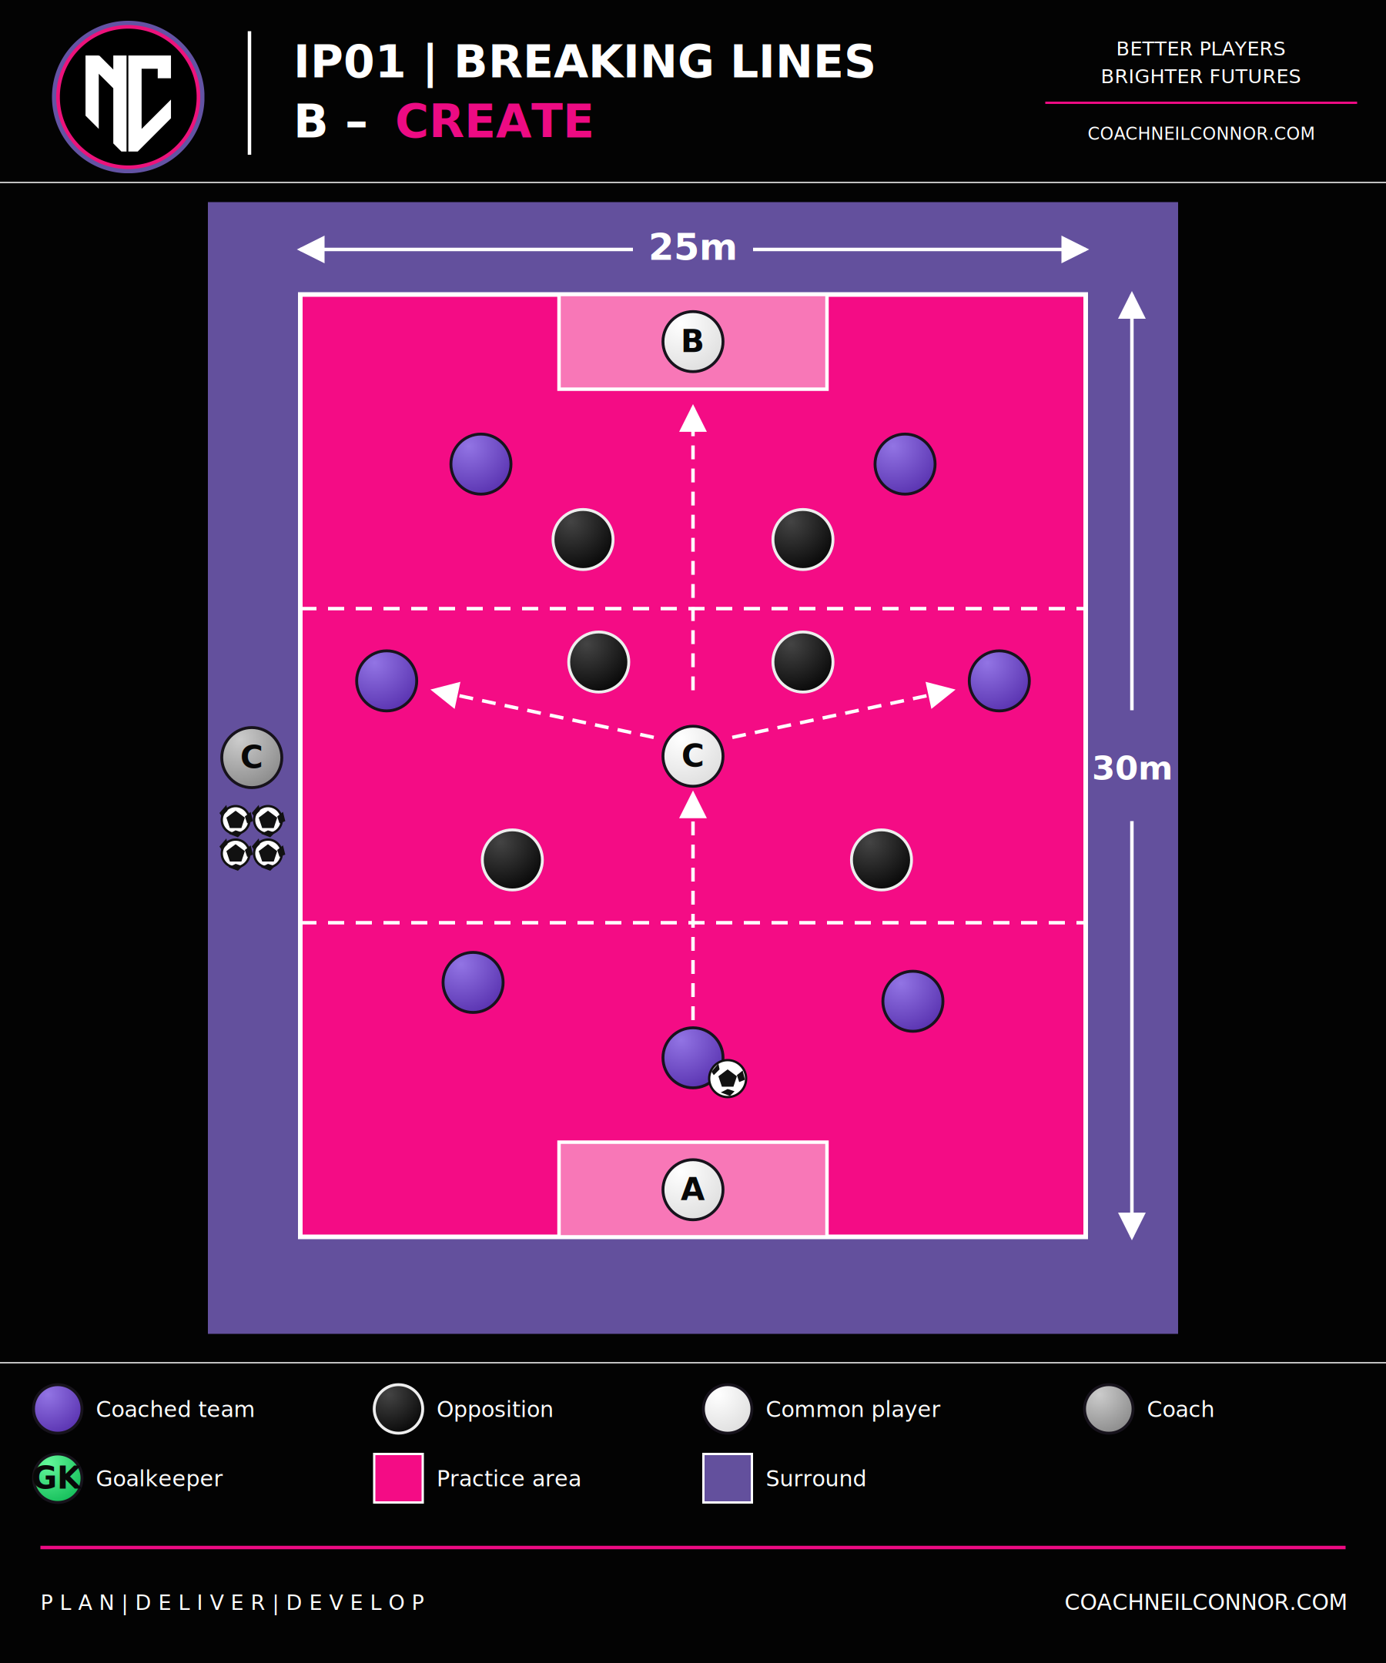

5 | PRACTICE C - EXPLOIT
Duration | 15 minutes
Practice Type | Directional Small-Sided Game
Organisation | 8v6 outfield + 2 goalkeepers + 1 common player (17 total). Purple attacks up; black attacks down. Start with the ball at purple 5. Thirds are references, not movement restrictions.
Area | Approx. 25m x 30m; adjust for player numbers and desired intensity.
Focus | Break a line and exploit the temporary advantage created.
Scoring: Normal goal = 1. Goal following a genuine line break = 3.
Qualifying line break: Pass through; combination through; carry/dribble beyond; progress around pressure then access beyond; or play over pressure.
PLAYER PROBLEM Once we break a line, can we exploit the advantage before the opposition recover?
Before the break: Scan; recognise pressure; position; create width/depth; find the spare player; pin or move opponents where appropriate.
During the break: Quality of pass/carry; receive forward; positive first touch; movement beyond; support around the ball.
After the break: Accelerate; support forward; attack available space; exploit before the opposition reorganises.
Progression (Harder): If players break lines but allow recovery, add a bonus for scoring within approximately six seconds of a successful line break. Remove the common player or reduce area if appropriate.
Regression (Easier): Increase area; retain common player; give common player greater freedom; reduce defensive numbers.
Coach Observation: Do not allow the practice to become a finishing session. Observe what created the line break and the actions immediately after it.

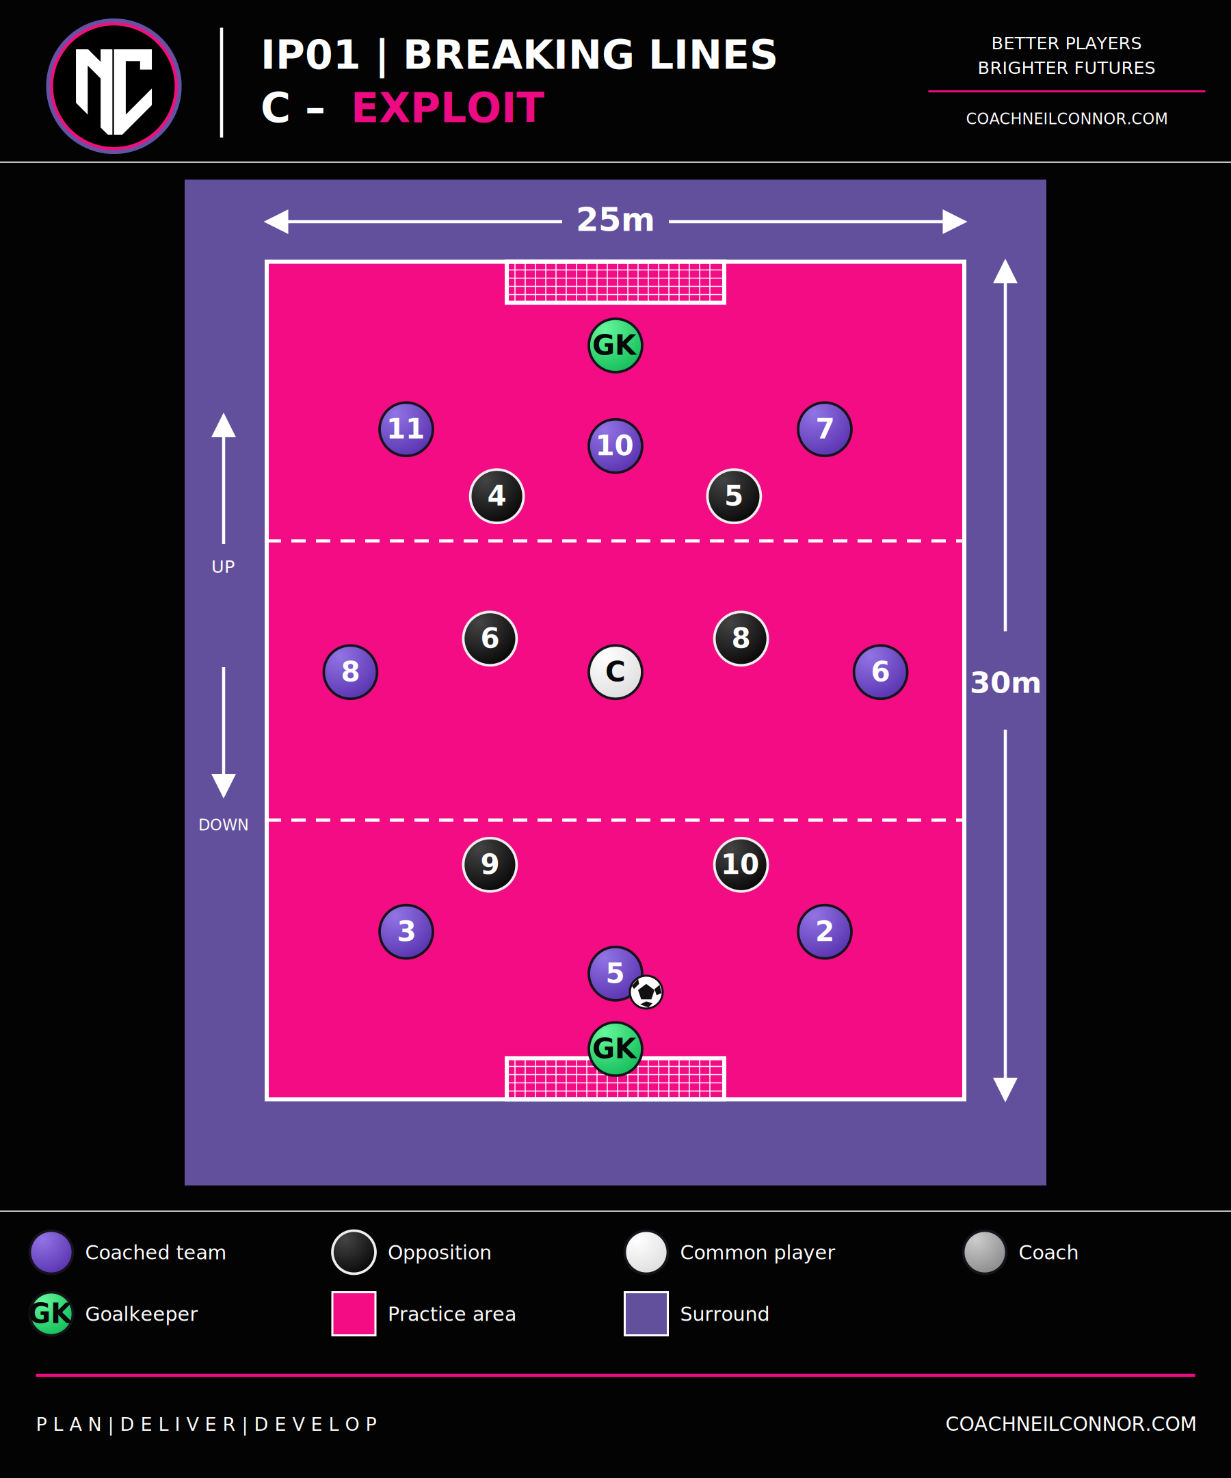

6 | 4-4-2 GAME - TRANSFER & CONSOLIDATE
Duration | 20 minutes
Practice Type | Representative Game
Reference | 4-4-2 relationships; reproduce positional relationships even if player numbers prevent full 11v11.
Structure | Block 1: coached game 8-10 min. Block 2: free game 10-12 min.
Block 1 - coached game: Minimal conditions. Look for transfer of the session principle into positional football.
• CB: recognise when to carry, play through, around or over.
• 6/8: find space beyond first pressure, receive forward and connect to the next line.
• FBs: provide the around solution and support balance.
• 7/11: provide width, move inside where appropriate and threaten beyond.
• 9/10: pin, connect, create space for one another and threaten behind.
• Team: maintain balance behind the ball while supporting forward progression.
Managed opposition: Protect central space; prevent split passes; force outside; protect behind; transition positively on regain.
Block 2 - free game: Remove bonus scoring and most conditions. Play football. Coach mainly through observation and concise concurrent information.
Transfer test: Do the Breaking Lines behaviours remain once the practice stops explicitly rewarding them?

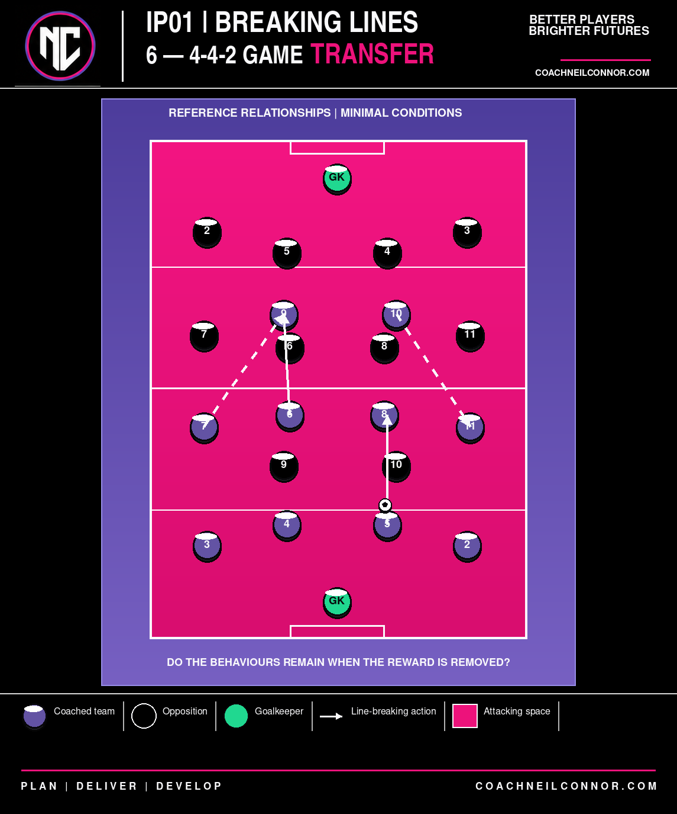

7 | PLAYER DEBRIEF - REFLECT
Duration | 3 minutes
Purpose | Consolidate understanding through concise player reflection.
• What tells us whether to play through, around or over?
• How can we create a spare player if one does not initially exist?
• What should we look to do immediately after breaking a line?
COACH REFLECTION - COMPLETE AFTER SESSION
Principle: Did players improve their recognition of through / around / over?
________________________________________________________________________________
Decision Making: Were decisions based on opposition pressure or simply on practice rules?
________________________________________________________________________________
Transfer: Did behaviours from A/B/C appear in the final game without prompting?
________________________________________________________________________________
Position Specific: Which relationships need further work: GK/CB, FB/Wide, CB/CM, CM/Forward, Front Two?
________________________________________________________________________________
Individuals: Who recognised pressure well? Who struggled to receive forward? Who failed to carry when unopposed? Who consistently found the spare player?
________________________________________________________________________________
Practice Design: What was too easy, too difficult, unnecessary or missing?
________________________________________________________________________________
Live Adaptation: What did I change during delivery, and why?
________________________________________________________________________________
Next Action: What learning should transfer into IP02 - Create & Exploit Overloads?
________________________________________________________________________________
FAW / SOURCE ALIGNMENT NOTES
Framework terminology and practice-design fields are aligned to the supplied FAW Welsh Way, FAW Breaking Lines General Practice, FAW Practice Design, and Coaches' Voice / SSP examples. This is an NC-branded planning document based on those structures; it is not an official FAW template.
• Welsh Way: Breaking Lines; Create & Exploit Overload.
• FAW practice fields: organisation/area, explanation, challenges/conditions/targets, key points and interventions.
• Coaches' Voice / SSP fields: focus area, players, timings, progressions/regressions and positional/individual detail.
• Advanced additions: session rationale, success indicators, opposition behaviour, transfer test and post-session reflection.

